2D AND 3D SHAPES
Pearson Edexcel – Specimen 2 - Paper 3 (Calculator) Foundation Tier

Pearson Edexcel – Sample Papers - Paper 3 (Calculator) Foundation Tier

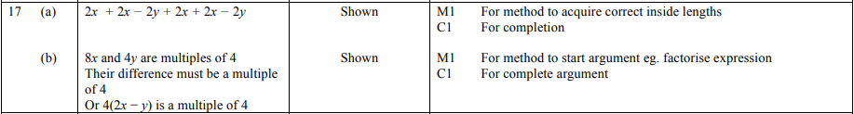
OCR Wednesday 8 November 2017– Morning (Calculator) Foundation Tier

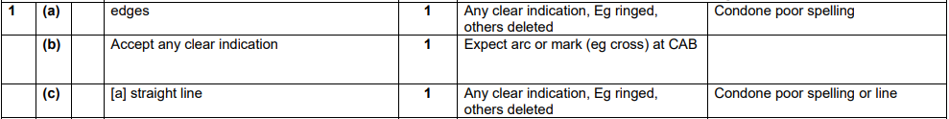
AQA Tuesday 12 June 2018 – Morning (Calculator) Foundation Tier

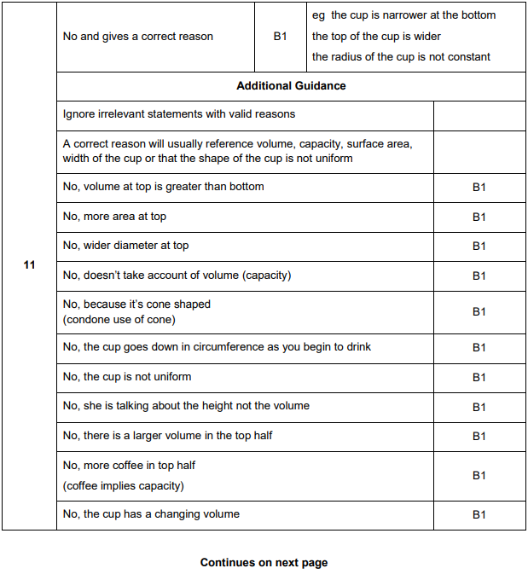
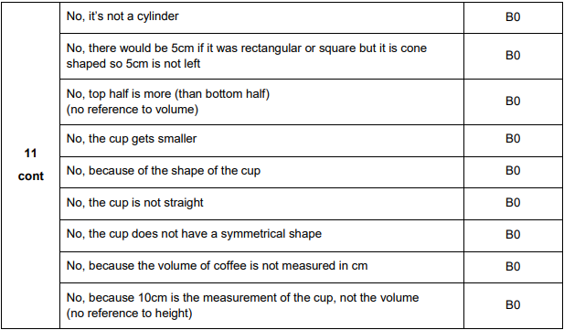
AQA Thursday 2 November 2017 – Morning (Non-Calculator) Foundation Tier

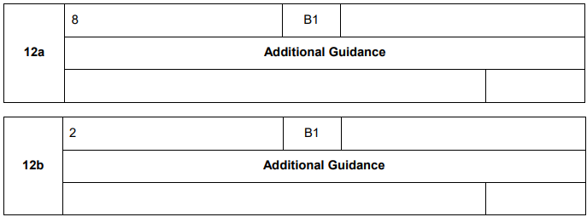

AQA Wednesday 8 November 2017 – Morning (Calculator) Foundation Tier

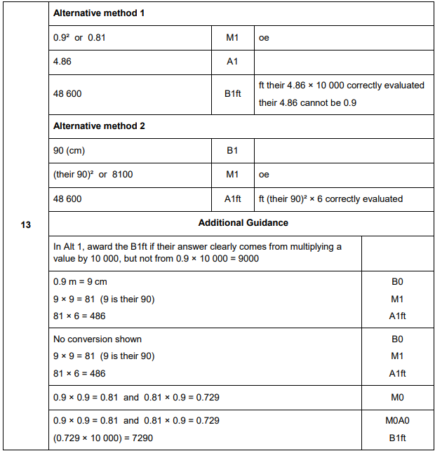

AQA Sample Paper 1– Morning (Non-Calculator) Foundation Tier

AQA Sample Paper 1– Morning (Non-Calculator) Foundation Tier

AQA Sample Paper 2– Morning (Calculator) Foundation Tier

